TRIGGER Form for SOC Vulnerability

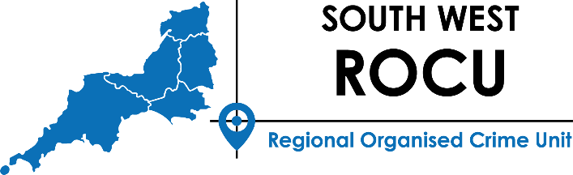

Once completed this form should be submitted to the ROCTA Inbox (SWROCTA@avonandsomerset.police.uk).

If the referral meets the criteria contained in the trigger form the ROCTA will carry out research / verification and MoRiLE score the SOC Threat for submission to regional SOC System Tasking for agreement. Completed research will be returned to the relevant owner. If the criteria and standards are not met, rationale for rejection will be provided and, where appropriate, recommendations for alternative action.

Serious & Organised Crime (SOC) Vulnerability Criteria

The following criteria will form the basis for nominations:
Is defined as a threat/risk which does not manifest itself as a group or individual. This will cover (a) SOC vulnerabilities or (b) tactical SOC issues that have a tasked response (Operations/Investigations). This could include criminal enablers, i.e., Borders vulnerable to exploitation; or a specific community being targeted by a specific SOC threat/crime series, i.e., Courier Fraud crime series.
Serious Crime: Serious crime is defined by section 93(4) Police Act 1997 as crime that involves the use of violence, results in substantial financial gain or is conducted by a large number of persons in pursuit of a common purpose, or crime for which a person aged 21 or over on first conviction could reasonably expect to be imprisoned for three or more years. Describe the main criminality being committed.

Referral Information
Date Submitted
Originating Organisation
Name, Email and Telephone contact details of Referrer
Priority Submission | Yes / No
URN
(To be completed by ROCTA)

Nominal Details (If identified)

Surname
Forename/s
DOB
Aliases
Nationality
PNC ID
Prison/status (If relevant)
Probation supervision
(If relevant)
Current Owning LEA / Force

Nominal Details (If identified)

Surname
Forename/s
DOB
Aliases
Nationality
PNC ID
Prison/status (If relevant)
Probation supervision
(If relevant)
Current Owning LEA / Force

Summary of Trigger Details
Please provide detail that support the SOC Vulnerability criteria
Criminality

Describe the main criminality being committed.
Intelligence / Operational Activity

Provide details of the intelligence / operational activity/ from the last 6 months

Geographic impact (please indicate the scope of impact if known)

Include areas of residence, criminal supply, travel etc. and any use of UK Borders
Please indicate if any checks have been completed in relation to any nominals, vehicles or addresses.
Checks could include ACRO, HMRC, HOIE, GAIN and financial checks – this is not an exhaustive list
Current Perceived Risk
Consideration should be given to Community impact, threats to individuals/violence and firearms – this is not an exhaustive list.
Please provide any other useful information here that would assist the decision maker.

To be completed by ROCTA

Initial Assessment
Date of Assessment | (Date the assessment is completed)
SOC Individual(s) Identified | Yes / No
Returned to originator | Rationale:
Priority | Yes / No

Initial Assessment - Checks Completed
System | Date

PND

PNC

Force System (To be amended per region to include a list of Forces)

SIU

GAIN+ Submission
(if appropriate)

SIENA (if appropriate)

Initial Assessment – Threat
MoRiLE Score (Up to Confidence Score)
MoRiLE Score (following LRO appointed)

