Request to Review Form



Referral Information
Date of Request:
Name, Email and Telephone contact details of Submitter:
OCG Reference Number:
Current OCG Score:
Current MoRiLE and P-Mech Score:
Reason for review:
Supporting evidence for review: | Brief summary of the OCGs criminality  Why do you believe the OCG should be reviewed?  How has it changed since the OCG was originally mapped?  What do you believe the outcome should be?

To be completed by ROCTA

Initial Assessment
Date of Assessment | (Date the assessment is completed)
Assessment completed by:
OCG Transferred | Yes / No

The ‘probability yardstick’ (as defined by the Professional Head of Intelligence Assessment) has been used to ensure consistency across the different threats and themes when assessing probability. The following defines the probability ranges considered when such language is used:
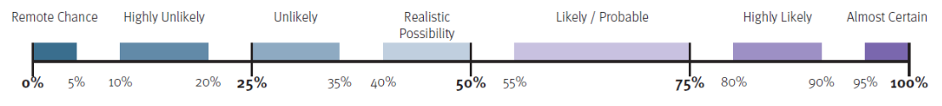

ROCTA Assessment
Signed Off : (ROCTA Manager)

