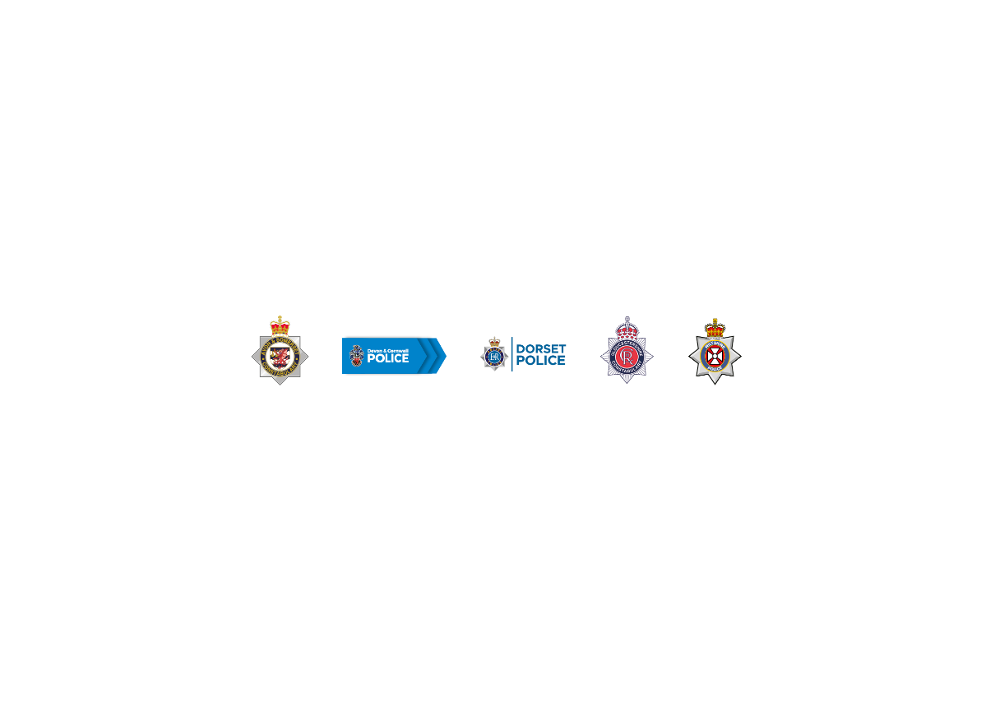
SOC THREAT
4P MANAGEMENT PLAN



OCG NAME:
OCG REFERENCE NUMBER:

Lead Responsible Officer
(Name and current post)
Plan Owner
(Name and current post)
Senior Investigating Officer
(Name and current post)

This document has been created to provide detail of management and activity in respect of the OCG or the Priority Individual. This document is marked as OFFICIAL-SENSITIVE-OPERATIONAL in accordance with GSC and should be handled, stored, and disseminated accordingly.

This document should be read in conjunction with documents relating to the OCG and/or Priority Individual that this plan relates to, which provide more information regarding their current activity, model, impact, and harm.

Guidance to assist Lead Responsible Officers create and deliver a 4P plan.

- It is advisable that the Lead Responsible Officers develop this plan utilising the Home Office Guidance for Lead Responsible Officers as the best practice guide to follow.

- LROs should create a structure and a team to ensure that the plan drives the activity across the 4Ps, assigning roles, responsibilities, and tasks to those best placed to deliver disruptions against a specific or broad threats. It is unlikely the LRO can achieve everything themselves, working in partnership is critical to the success of the plan. A SIO should be identified and responsible for driving elements of the plan, particularly the PURSUE pillar of disruption and enforcement.

- Set clear Aims and Objectives and ensure the plan activity links to those, ensuring it drives the response to the threats identified.

- Identify key partners, both internal and external, who can be involved in the 4P plan from the outset and be assigned responsibility for delivering aspects of the plan. Utilise existing forums for sharing information to develop a common understanding of the issues and galvanise support across partnerships to tackle them, generating opportunities to work together in the most effective way to disrupt the OCG.

- Understand all possible vectors of enforcement available, using the 6 topic areas within the College of Policing Menu of Tactics as a guide. Police enforcement opportunities can often be limited, bringing in partners and their enforcement tactics can broaden the scope of disruption of the OCG.

- Understand the geographic and place-based impact of the OCG, the vulnerabilities they are exploiting to cause harm and the drivers of SOC in the area, for example poverty or lack of services. This will inform what preventative and diversionary interventions that can be developed as part of the 4P plan.

- The 4P plan works alongside other products such a an “OCG Plan on a Page” or criminal investigation. Understanding the gaps in information and intelligence will be key to what action is required to establish opportunities to disrupt. Information sharing with partners should be a core part of the plan, making the best use of the Government Agency Intelligence Agency (GAIN) to access partnership data and understand what other capabilities could help, such as the Regional Disruption Team in the ROCU

- Seek Peer Support to check and test your plan, share learning, ideas and best practice. Connect with the Serious Organised Crime Coordinators at the ROCU to unlock further ideas and opportunities to develop the plan.

- Disruption activity should include reaching into specialist teams, ensure everyone understands their role in tackling the OCG. Ensure that you are connected to the ROCU, if you are local force LRO, and vice versa if you are ROCU LRO, to ensure there are clear lines of communication and a supportive relationship.

- Review the plan in accordance with the period required in relation to the TIER of the OCG/PI. Retain the plan in accordance with force or ROCU’s policies, but it should be visible to those that need to be part of the response and include how partners can update it if required.

- Keep it simple and don’t over complicate the plan! Taking small steps to make it difficult for OCGs to operate can have significant impact.

Part A - Scanning and Analysis

Current MoRiLE 2020 |  | ORI |  | P Banding |  | Tier of Response (1-4)
Intelligence Manager |  | Financial Investigator |  |  | Analyst
Start Date |  | Date of this plan |  |  | Date of next review – linked to TIER of OCG

Problem-solving policing | College of Policing

Summary of SOC threats being tackled
Concise assessment of the OCG/Priority Individual (PI) model and MO, the SOC threats that this plan relates to, the vulnerabilities being exploited, the place-based issues and geographic impact, who is at risk (people/places/organisations), professional enablers involved. This drives the response within the plan. Full details held in associated products.

Intelligence Development Strategy
Set out the methodology to be employed to maximise the intelligence and information obtained about the OCG,PI, SOC Threats. This should include what gaps exists, the mechanism to reach into the community and how to obtain and share intelligence with partners. Include how you will be using the Government Agency Intelligence Network (GAIN) and SWROCU

Partnerships
Concisely detail key stakeholders and interested parties who will be used to deliver activities or consulted on what needs to happen to tackle the threat. Detail who you are coproducing this plan with.

Strategic aims and objectives and areas of focus to tackle and disrupt the Organised Crime Group (OCG) or Priority Individual (PI)

The Lead Responsible Officer (LRO) should set the areas of focus for tackling and disrupting the OCG/PI, considering activity across the 4 Ps. These should be regularly reviewed throughout the lifecycle of the OCG/PI from creation and allocation, through developing an improved understanding of the group to disruption and associated impact etc. The strategic objectives should also consider the intelligence picture.

When setting the strategic objectives and areas of focus:
- Consider what is known but also what is unknown and/or unclear about the OCG/PI, the members, the criminality involved and the associated threat/impact (i.e. intelligence gaps);
- Consider safeguarding and vulnerability.
- Consider working in partnership with other agencies, forces, and regional assets.
- Reflect activity across the 4Ps.

Aim
What is the overarching outcome you hope to achieve with your 4P SOC Management plan?

Objectives
How will each P contribute towards the aim? You should not include your responses in the objective.
Having defined your objectives, you need to identity how you’re going to measure this.
Review below and select the objectives that are relevant following your assessment of the OCG/PI, adding others where appropriate. These should set the focus for the Plan Owner and associated tactical activity to tackle and disrupt the OCG/PI (add ‘Y’ in the box for those that you select).

PURSUE OFFENDERS THROUGH PROSECUTION AND DISRUPTION | PRIORITISE/SELECT BASED ON AN ASSESSMENT OF THE OCG/PI | PREVENT PEOPLE FROM ENGAGING IN SERIOUS AND ORGANISED CRIME | PRIORITISE/SELECT BASED ON AN ASSESSMENT OF THE OCG/PI
Develop the intelligence picture to improve understanding of the OCG/PI and associated criminality and in turn identify tactical options (people, locations, vehicles, finances, businesses, MO etc.) |  | Undertake direct intervention with OCG/PI members to prevent further criminality (enforcement of bail conditions, orders, licence conditions, serving of warning/deterrence letters/criminality notices etc.).
Assign/identify resources to investigate the criminal activity of the OCG/PI (overt and covert tactics). |  | Implement direct intervention with locations and business associated to the OCG/PI's criminality (closure orders etc.).
Disrupt the activities of the OCG using a variety of police and partner tactics and legislation (target vehicles (ANPR), arrest for non OCG/PI related offending, increase activity where the OCG/PI operates/impacts, plan and execute warrants, multi-agency days of action etc.). |  | Identify and risk assess individuals recognised/highlighted as being vulnerable to being drawn into SOC and/or exploited by this group, with multi-agency referrals and preventative work (including family members).
Target the OCG/PI's criminal finances and associated businesses. |  | Raise awareness of the risks of becoming involved in the OCG/PI’s activity (focus on a particular geographic area, specific type of offending etc.).

PROTECT INDIVIDUALS, ORGANISATIONS AND SYSTEMS FROM THE EFFECTS OF SERIOUS AND ORGANISED CRIME | PRIORITISE/SELECT BASED ON AN ASSESSMENT OF THE OCG/PI | PREPARE FOR WHEN SERIOUS AND ORGANISED CRIME OCCURS AND MITIGATE IMPACT | PRIORITISE/SELECT BASED ON AN ASSESSMENT OF THE OCG/PI
Identify potential victims/vulnerable individuals targeted by the OCG/PI's criminal activity and implement associated safeguarding and referrals. |  | Undertake activity to raise awareness of the impact of SOC and to ‘de-glamorise’ the OCG/PI's activity.
Protect individuals from violence and intimidation linked to the OCG/PI’s criminal activity (threats, tensions, disputes with other OCG/PIs etc.) |  | Undertake community engagement in partnership with other agencies including the third/voluntary sector.
Identify and protect locations/geographic areas vulnerable to the activities of the OCG/PI. |  | Ensure all relevant officers, staff and partner agencies are appropriately briefed regarding the threat posed by the OCG/PI and criminality involved.
Protect businesses through awareness raising and direct activity to improve their resilience to the impact of the OCG/PI. |  | Prepare for successful enforcement activity and keep the community updated, including considering the benefits of community impact assessments and statements and surveys before and after activity.

LRO Update
What activity has taken place during the last review period, what does that mean in the context of the OCG/PI’s threat, harm, and risk and what is the focus during the next review period.
General summary – provide the current rich picture, the risks that exists, any capabilities or resourcing issues, connection to specialist teams and partnership response.
Does not have to be the case management log, LROs can track that using force systems.

Part B – Response and Assessment

Tactical Activity and Action Log

Plan Owners should use the following section to record the tactical activity and action that is allocated and undertaken to tackle and disrupt the OCG/PI based on the strategic objectives and focus given by the LRO. This must include an assessment of the impact of the activity taken. The LRO should regularly review the Tactical Activity and Action Log in conjunction with the Plan Owner.

GUIDANCE
Which 4P does the action required align to?  - Actions can align to more than one 4P (Pursue, Prevent, Protect, Prepare)- please ensure at least one is recorded or more than one where appropriate.  Status:  - GREEN- Action complete.  - AMBER- Action ongoing and on track to be delivered by the target date.  - RED- Action not started or not on track to be delivered by the target date. | Disruption assessment- please assess the impact of the specific activity against the OCG’s threat and harm i.e.:  - NEGATIVE – adverse impact – the activity led to an increase in the OCGs capability.  - NONE – no discernible impact on the OCG or individual – a short term change.  - MINOR – minimal, short-term impact on the capability of the OCG or individual.  - MODERATE – noticeable, medium term disruptive impact on the capability of the OCG or individual.  - MAJOR – significant, long-term impact on the capability of the OCG or individual.

Disrupting serious and organised criminals – menu of tactics | College of Policing

PREPARE

RESPONSE |  |  |  | ASSESSMENT
Date | Action/Planned Activity | Owner  (name/agency) | Update/result | Status | Disruption Assessment | Submitted Y/N

PREVENT

RESPONSE |  |  |  | ASSESSMENT
Date | Action/Planned Activity | Owner (name/agency) | Update | Status | Disruption assessment | Submitted Y/N

PROTECT

RESPONSE |  |  |  | ASSESSMENT
Date | Action/Planned Activity | Owner  (name/agency) | Update/result | Status | Disruption Assessment | Submitted Y/N

PURSUE

RESPONSE |  |  |  | ASSESSMENT
Date | Action/Planned Activity | Owner  (name/agency) | Update/result | Status | Disruption Assessment | Submitted Y/N

